Version 1.0
24/10/2019

Alan DUFFIN
X00159409
cERTIFICATE, CLOUD SOLUTIONS ARCHITECTURE 2019, PROJECT

TECHNICAL ASSESSMENT

Table of Contents

AREAS OF INVESTIGATION 3
TECHNICAL ARCHITECTURE 4
AZURE SERVERLESS (FUNCTIONS AS A SERVICE) 6
AZURE NOSQL 13
AWS IAM 21
AWS SERVERLESS (FUNCTIONS AS A SERVICE) 25
AWS NOSQL 29
AWS WORKFLOW AND ORCHESTRATION 33
REFERENCE LIST AND BIBLIOGRAPHY 42

AREAS OF INVESTIGATION

In order to begin the Implementation Phase of the project it will be necessary to undertake a preliminary technical assessment of the available Functions as a Service (FaaS), Serverless and Workflow / Orchestration services that are provided by the main Cloud vendors.

To this end, this document will outline the specific services that are available from Microsoft Azure and Amazon Web Services. To build a working system other services such as NoSQL and Authorisation/Authentication will be required and they will also be covered although in less depth are they are not the focus of the problem domain that is under investigation.

The list of Services are outlined next.

Amazon Web Services provides the following services that would be required:
- AWS Identify and Access Management
- AWS DynamoDB (NoSQL)
- AWS Lambda (Serverless)
- AWS Step Functions (Workflow)

Microsoft Azure provides the following equivalent services:
- Azure Role Based Access Control (RBAC)
- Azure Cosmos DB (NoSQL)
- Azure Functions (Serverless)
- Azure Logic Apps (Workflow)

TECHNICAL ARCHITECTURE
As described above the basic architecture for the project if implemented on the AWS platform would involve the servers shown in the architecture diagram below. (Figure AWS.ARCH.1)

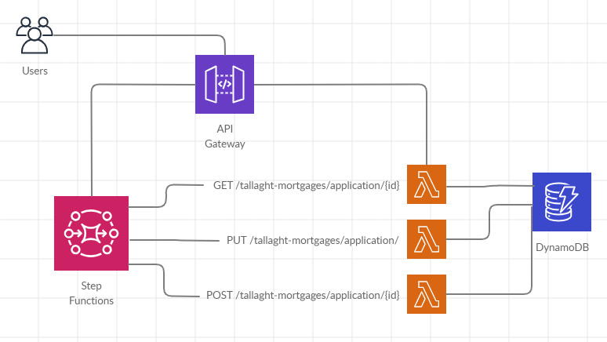
Figure AWS.ARCH.1

AZURE SERVERLESS (FUNCTIONS AS A SERVICE)
The Azure Serverless offering is called Azure Function Apps. In this section I will outline the steps that I have taken to build and deploy a simple component.

Step 1: Navigate to the Microsoft Azure Function App console and select Create. (Figure AZ.FUNC.1)
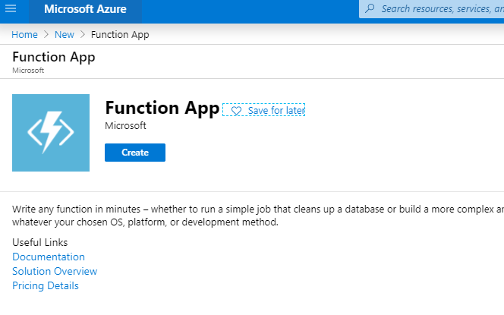Figure AZ.FUNC.1

Step 2: Create a Resource Group and select a Function App name. (Figure AZ.FUNC.2)
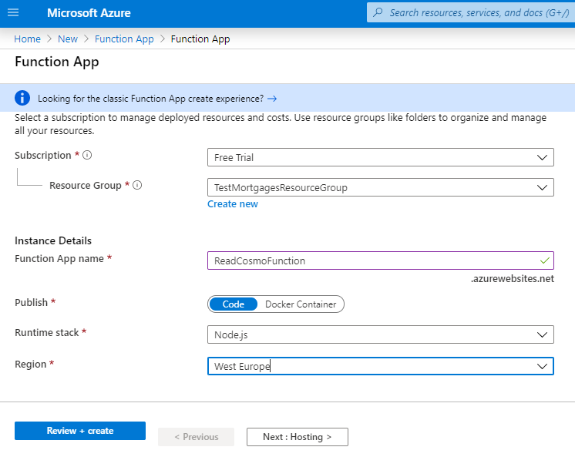Figure AZ.FUNC.2

Step 3: Select the Create option. (Figure AZ.FUNC.3)
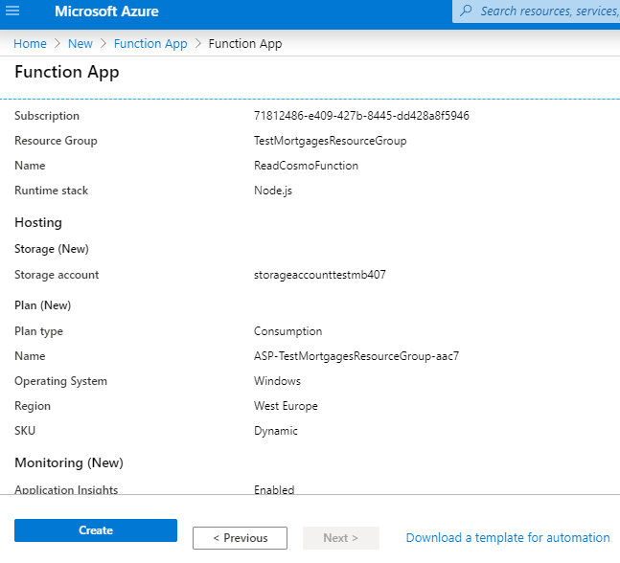Figure AZ.FUNC.3

Step 4: The Function App should take a few minutes to create. (Figure AZ.FUNC.4)
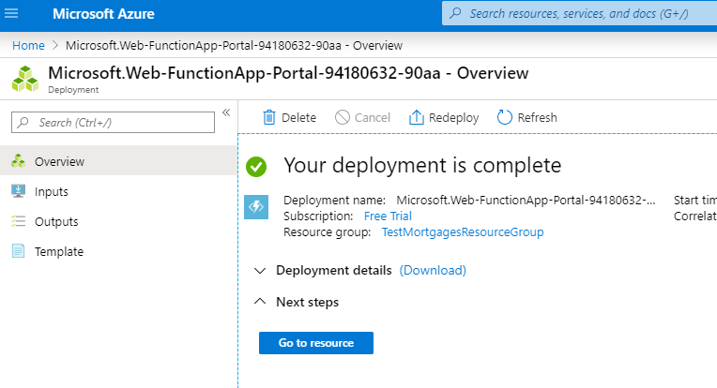Figure AZ.FUNC.4

Step 5: Select Go to Resource. (Figure AZ.FUNC.5)
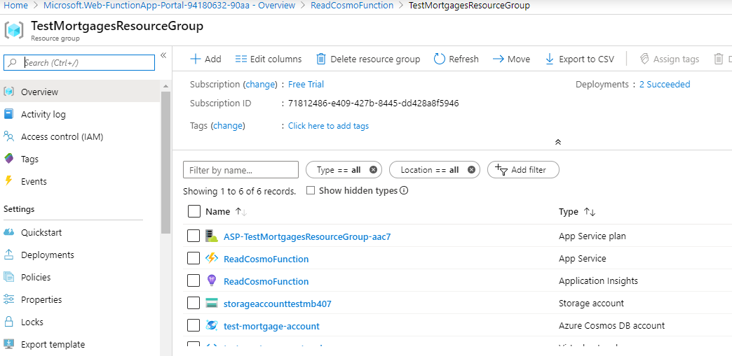Figure AZ.FUNC.5

Step 6: Add the Function Code. (Figure AZ.FUNC.6)
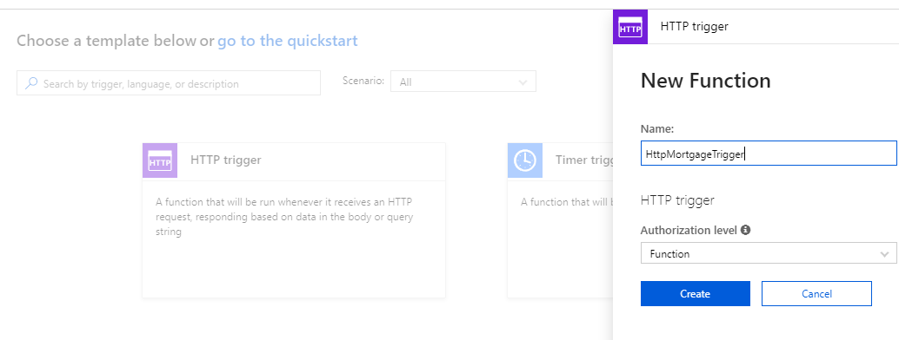
Figure AZ.FUNC.6

Step 7: In order to use NodeJS modules it is necessary to login to the Kudu Configuration terminal for the Function App. (Figure AZ.FUNC.7)
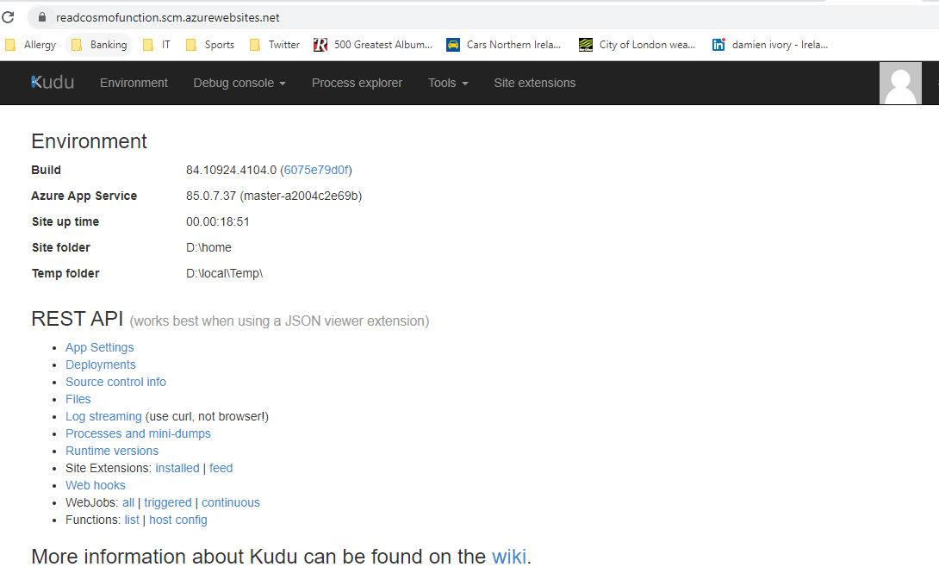
Figure AZ.FUNC.7

Step 8: Create a package.json file in the folder wwwroot/. (Figure AZ.FUNC.8)
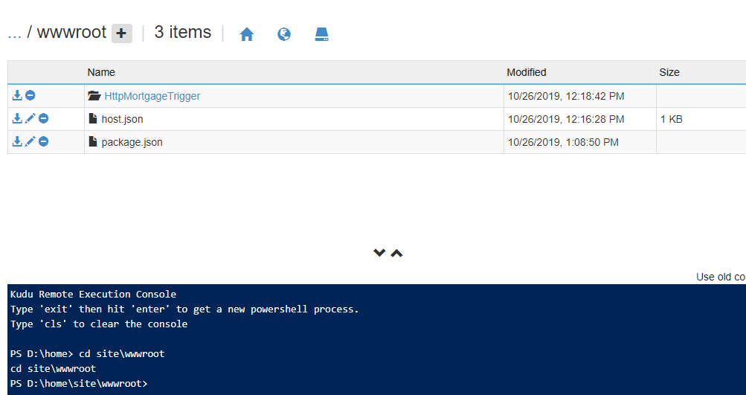
Figure AZ.FUNC.8.

Step 9: Edit the code to connect to the Database server. (Figure AZ.FUNC.9)
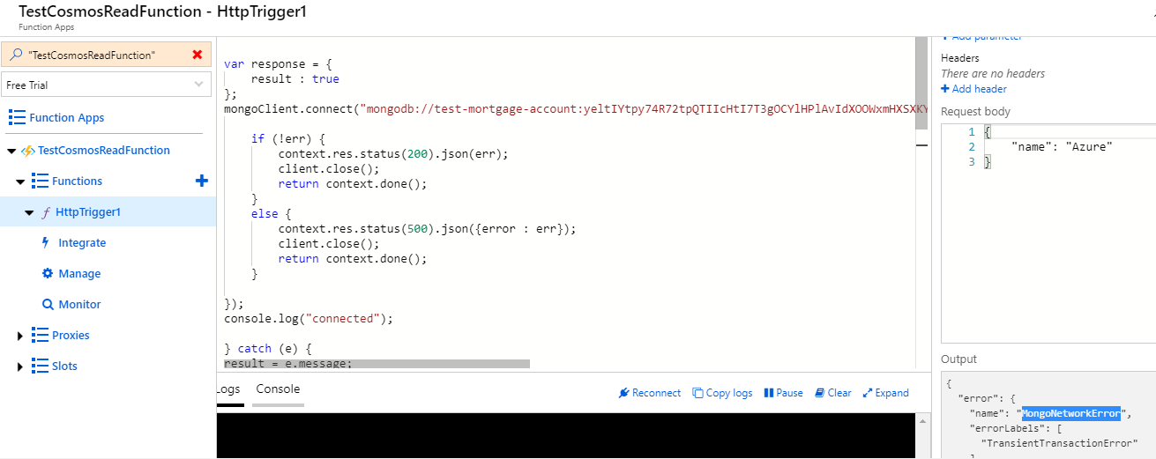
Figure AZ.FUNC.9.

I have been unable to get the code to work successfully before the project deadline. There have been various errors such as:

{
"error": {
"name": "MongoNetworkError",
"errorLabels": [
"TransientTransactionError"
]
}
}

Other errors have include “MongoError – Authentcation Error”.

I have found the Azure services, user console, development guides, logging and other features to inferior to the AWS development environment and literature.

My attempt to use the Visual Studio Code IDE and deployment tools did not succeed either. The error produced is seen in Figure AZ.FUNC.9. Apparently Azure Function bindings can only be used with SQL libraries.

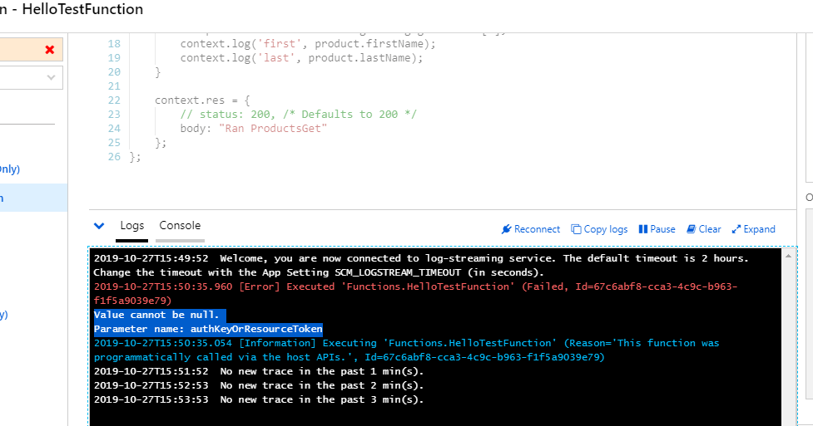
Figure AZ.FUNC.9.

AZURE NOSQL

Step 1: Create a Cosmos DB Account. (Figure AZ.COSMOS.1)
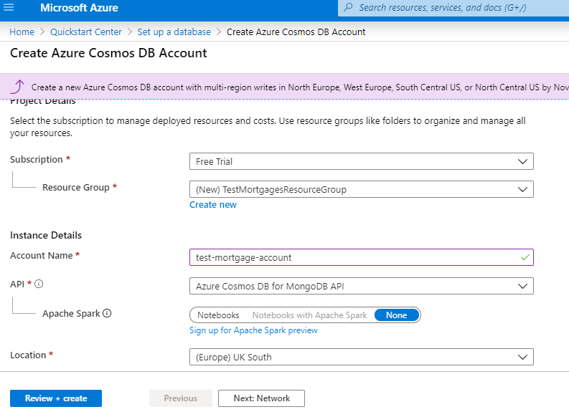
Figure AZ.COSMOS.1

Step 2: Configure the Virtual Network and Firewall. (Figure AZ.COSMOS.2)
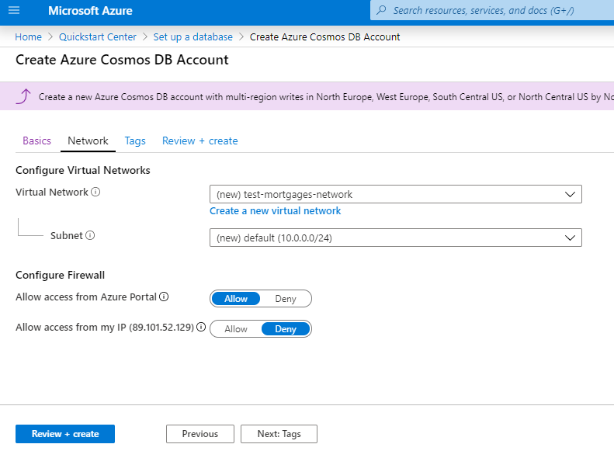Figure AZ.COSMOS.2

Step 3: Review the Cosmos DB Account. (Figure AZ.COSMOS.3)
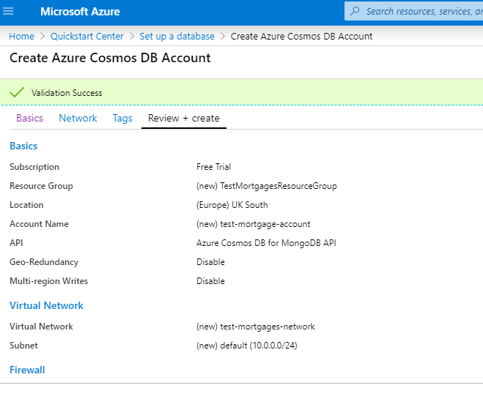Figure AZ.COSMOS.3.

Step 4: The deployment will take a number of minutes to complete. (Figure AZ.COSMO.4)
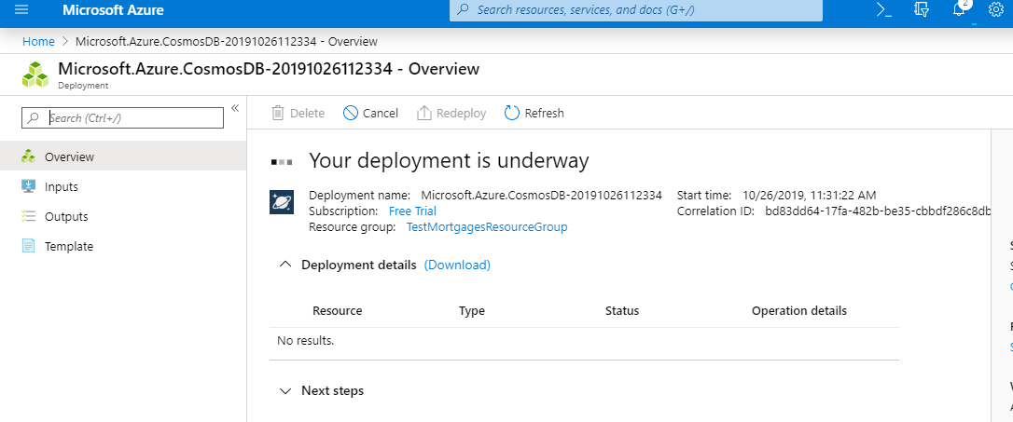Figure AZ.COSMO.4

Step 5: Once the deployment is complete, select Go to resource. (Figure AZ.COSMOS.5)
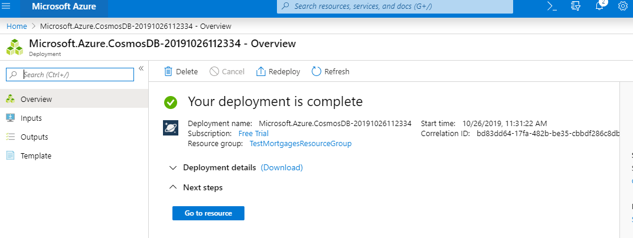Figure AZ.COSMOS.5

Step 6: Select the NodeJS platform in order to obtain starter code that will allow us to connect to the database. (Figure AZ.COSMOS.6)
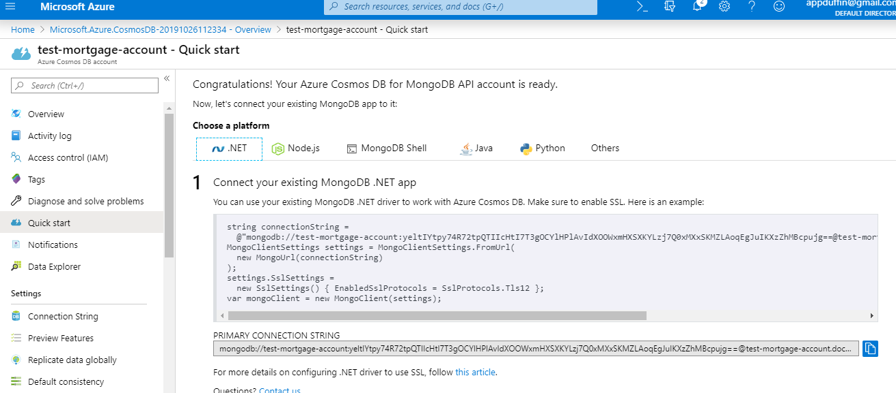Figure AZ.COSMOS.6

Step 7: Add a Collection to the new NoSQL database. (Figure AZ.COSMOS.7)

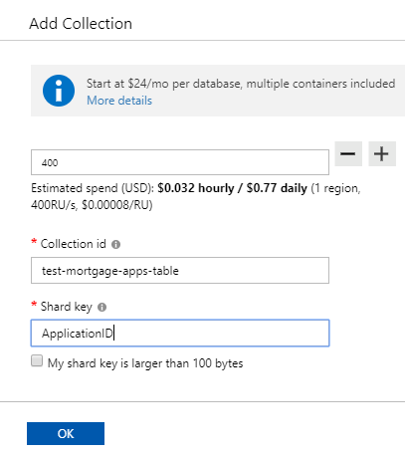
Figure AZ.COSMOS.7

Step 8: Add the local IP address to the Firewall to allow access from the home device via the Web Console. (Figure AZ.COSMOS.8)
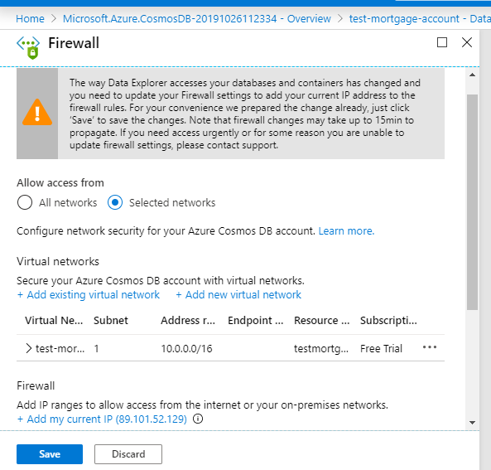
Figure AZ.COSMOS.8

Step 9: Add a document/Item to the Collection that we can use during testing of the Azure Function.
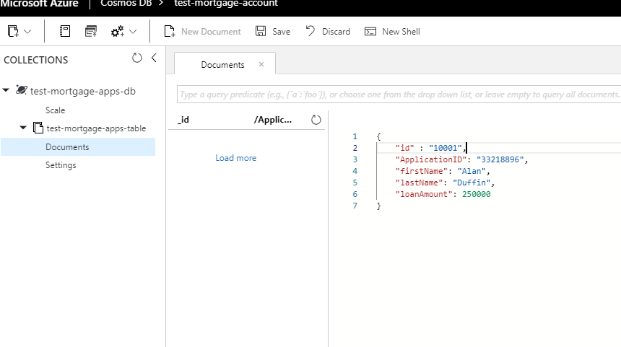
Figure AZ.COSMOS.9.

AWS IAM
To allow another AWS service or custom code to access the datastore, in this case DynamoDB, an IAM Role needs to be created that contains the appropriate permissions. For this investigation phase we can include just Scan, Query and GetItem permissions.

Step 1: Navigate to the IAM Console.
Step 2: Select Create Role. (Figure AWS.IAM.1)

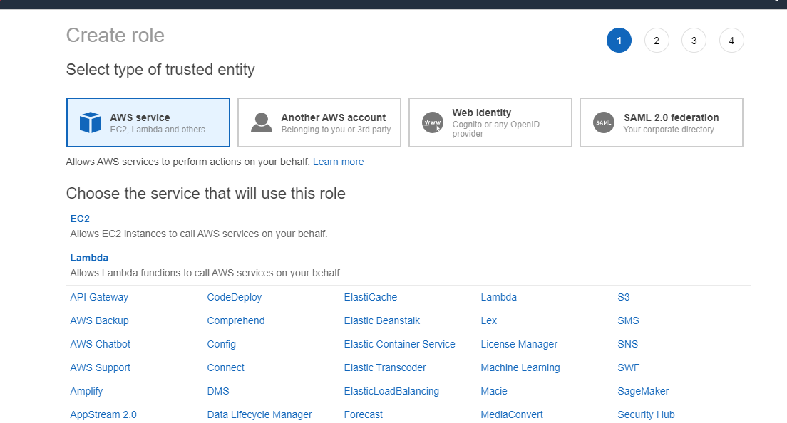
Figure AWS.IAM.1

Step 3: Select the required Access Permissions. (Figure AWS.IAM.2)
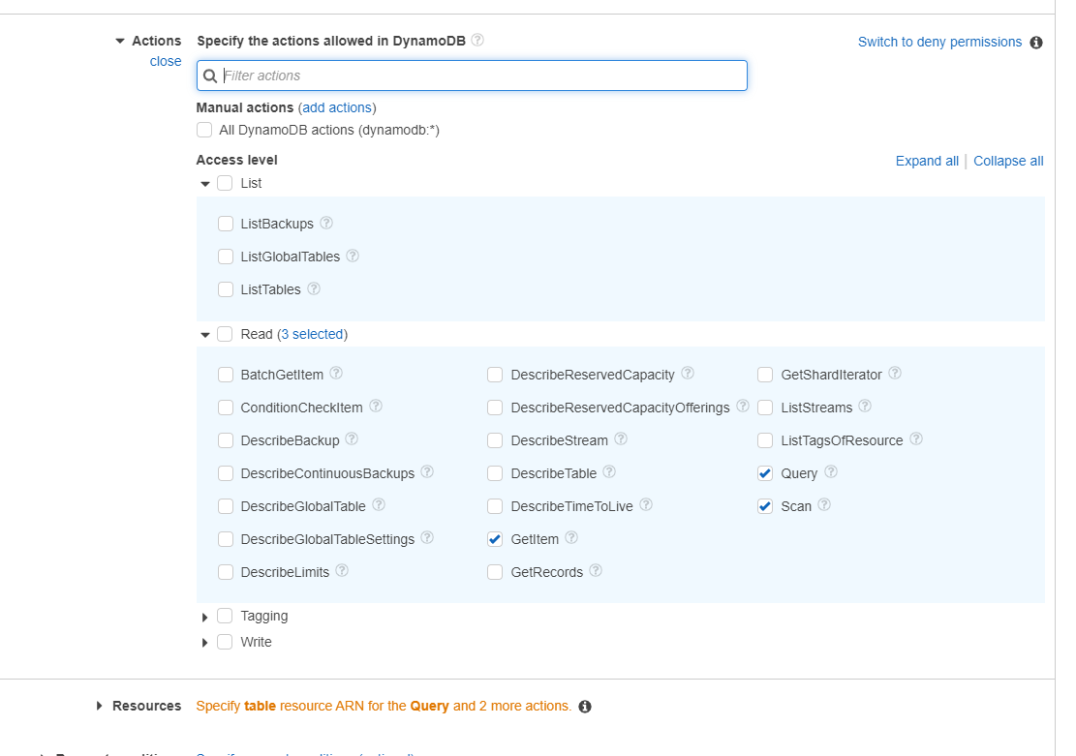
Figure AWS.IAM.2

Step 4: Name and Review the Policy. (Figures AWS.IAM.3, AWS.IAM.4)
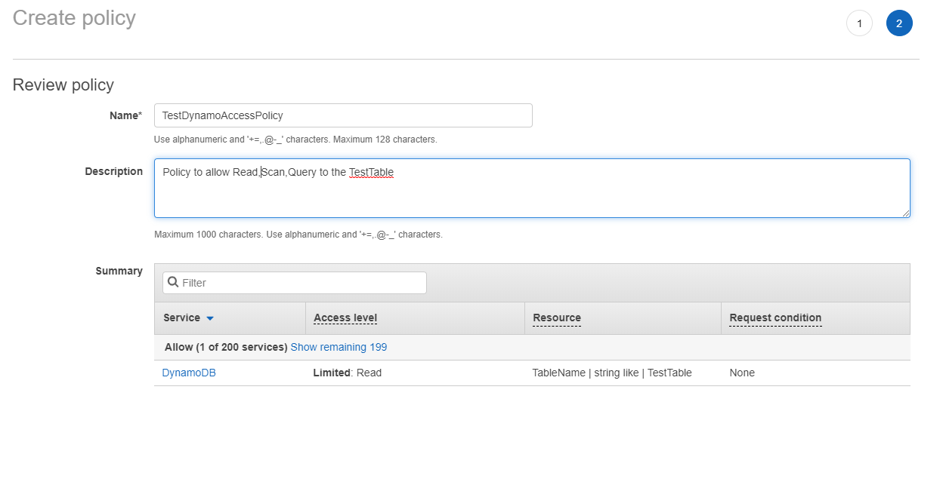
Figure AWS.IAM.3

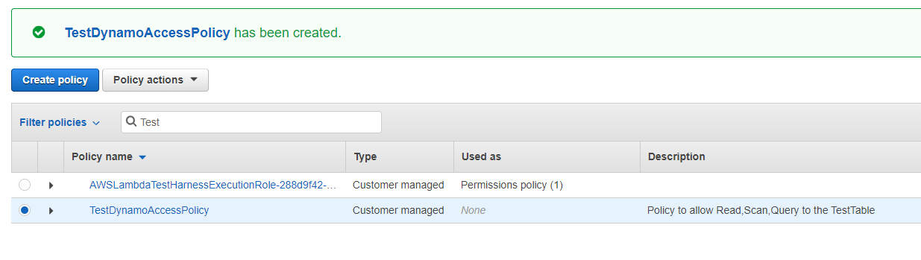
Figure AWS.IAM.4

Step 5: Add the Policy to the new Role. (Figure AWS.IAM.5)
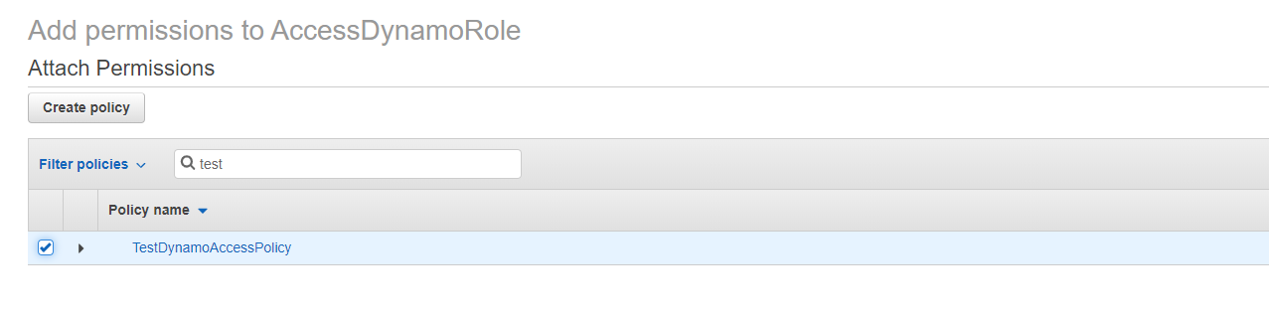
Figure AWS.IAM.5

AWS SERVERLESS (FUNCTIONS AS A SERVICE)

The AWS FaaS/Serverless offering is called AWS Lambda. In order to implement the project I will need to create a small suite of Lambda functions that will perform tasks such as reading, writing to a persistent data store, sending notifications of Mortgage Application state changes etc.
The following are the basic steps that are required in order to create a Lambda function.

Step 1: Navigate to the AWS Lambda Console. (Figure AWS.LAMBDA.1)
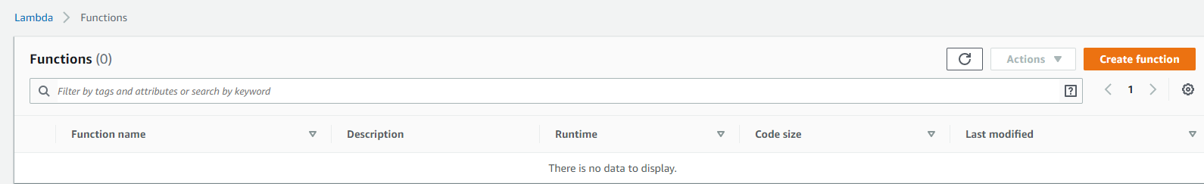
Figure AWS.LAMBDA.1

Step 2: Select Create Function. (Figure AWS.LAMDBA.2)
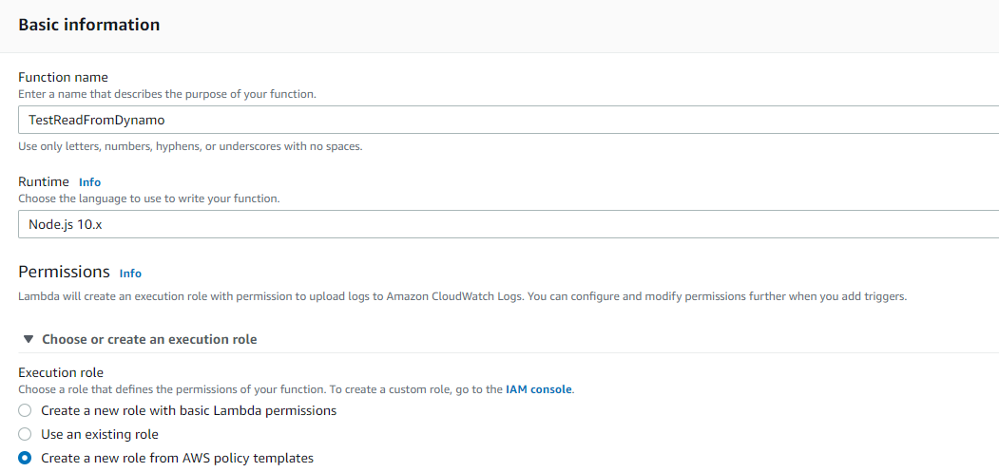
Figure AWS.LAMBDA.2

Step 3: Use an existing IAM Role and Choose the Role from previous section. (Figure AWS.LAMBDA.3)
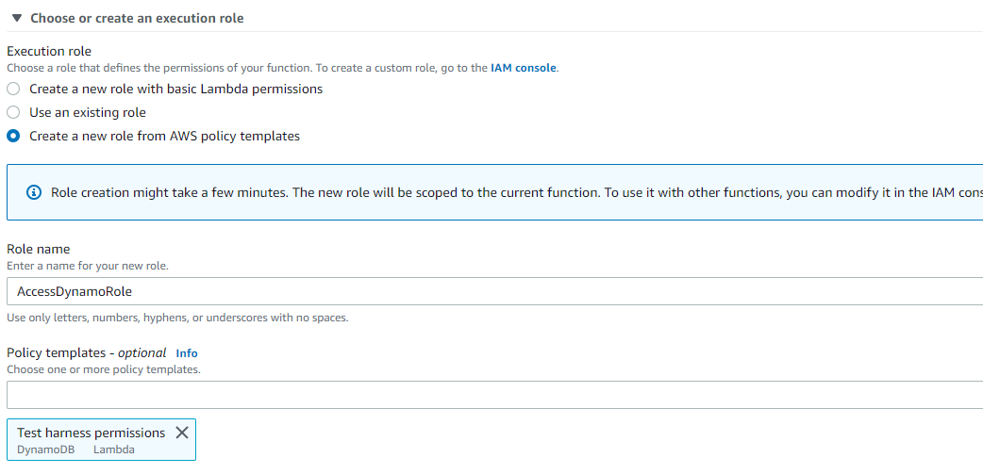
Figure AWS.LAMBDA.3

Step 4: Confirmation of new Function. (Figure AWS.LAMBDA.4)
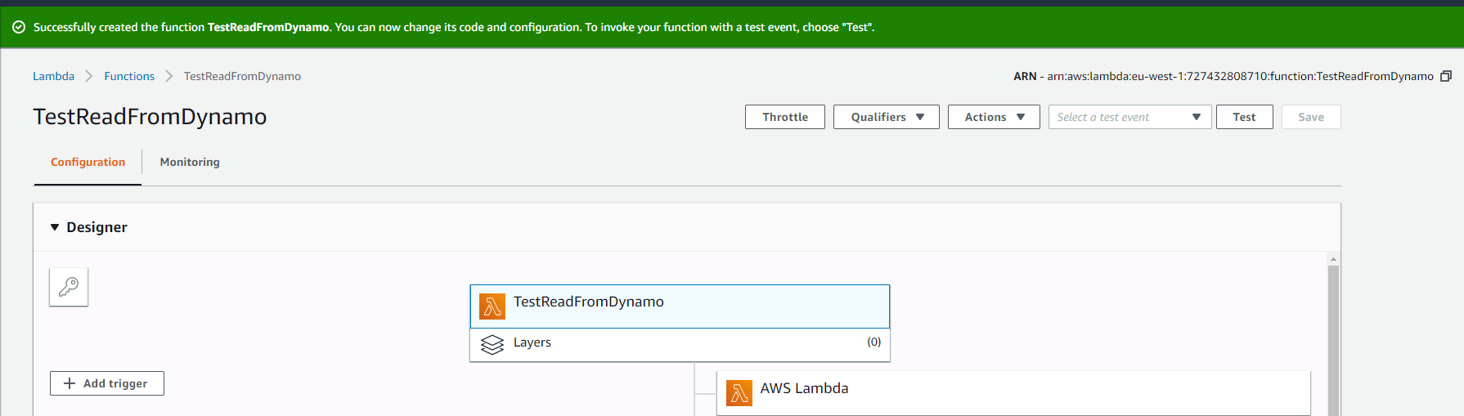
Figure AWS.LAMBDA.4

Step 4: Begin to input the source code. (Figure AWS.LAMBDA.5)
This code makes a simple call to read an Item from the NoSQL data store.

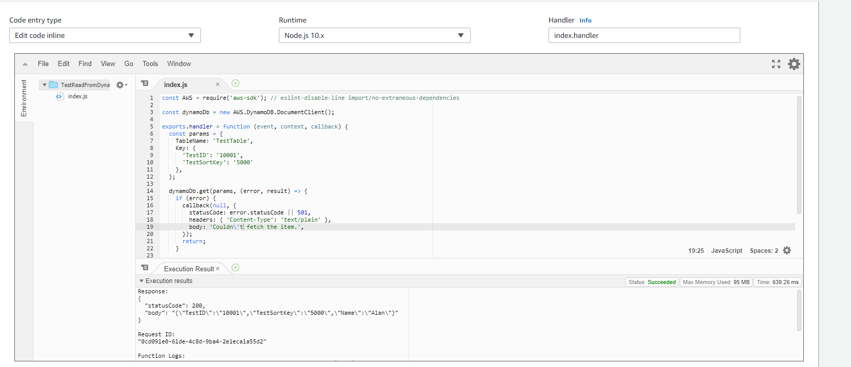
Figure AWS.LAMBDA.5

Step 5: Create a Test Event. (Figure AWS.LAMBDA.6)
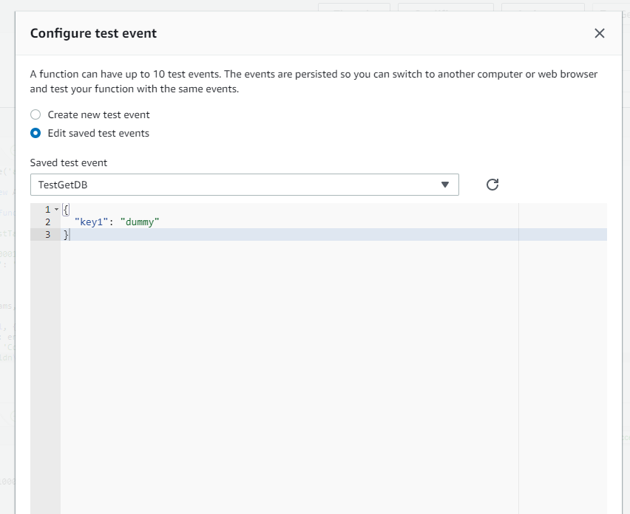
Figure AWS.LAMBDA.6

Step 6: Fire the Test Event. (Figure AWS.LAMBDA.7)
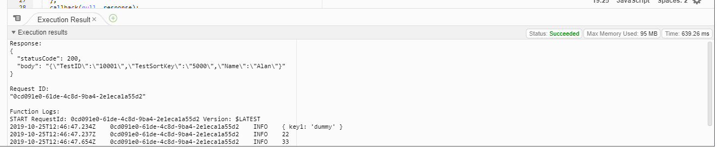
Figure AWS.LAMBDA.7

AWS NOSQL

It will be necessary to store individual Mortage Applications, therefore I require a Cloud provisioned Database. For expediency, I will investigate the most popular NoSQL services that are available from Azure and AWS. The AWS NoSQL offering is called DynamoDB. The following steps outline the simple tasks that are required to create a DynamoDB table.

Step 1: Navigate to the DynamoDB Console. (Figure AWS.DB.1)
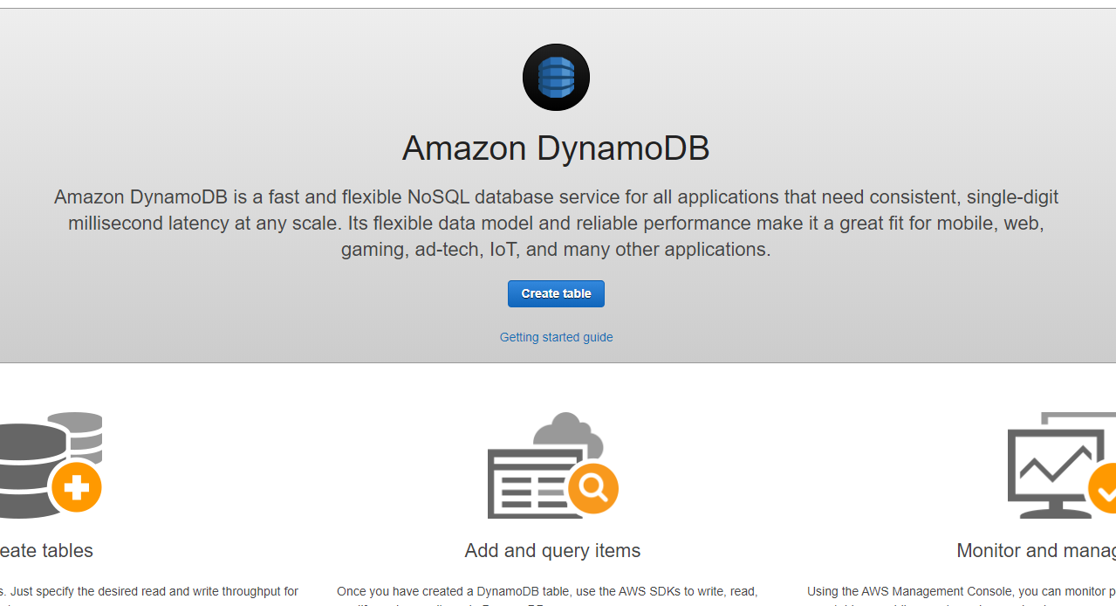
Figure AWS.DB.1

Step 2: Select Create Table. Figure (AWS.DB.2)

Step 3: Input a Partition Key Name and Type. The Partition Key must be an efficient Hash value that will result in effective distribution of table Items across logical partitions. Figure (AWS.DB.2)

Step 4: If required, Create a Composite Primary Key by specifying a Sort Key. Figure (AWS.DB.2)
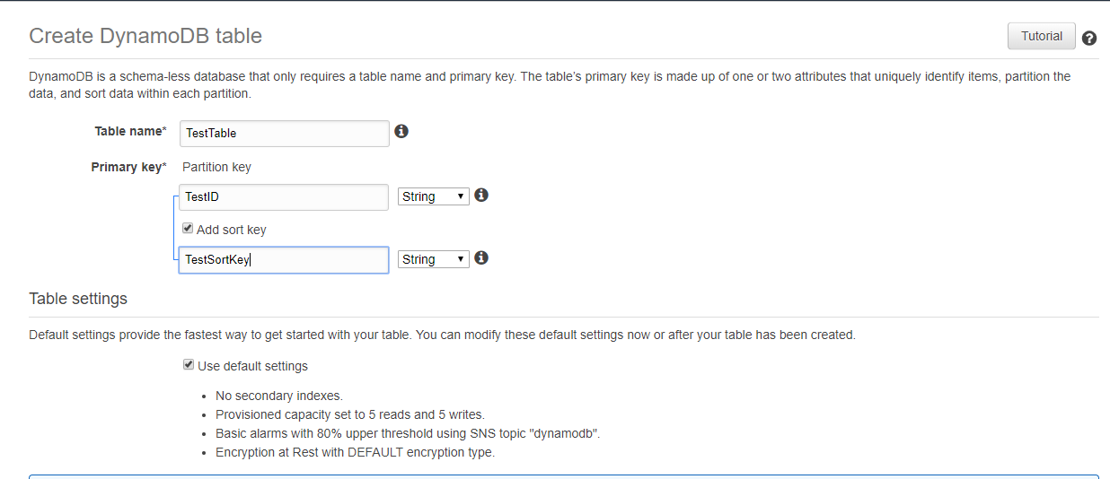
Figure (AWS.DB.2)

Step 5: Create the Table. Wait for the Table to be Provisioned. (Figure AWS.DB.3)
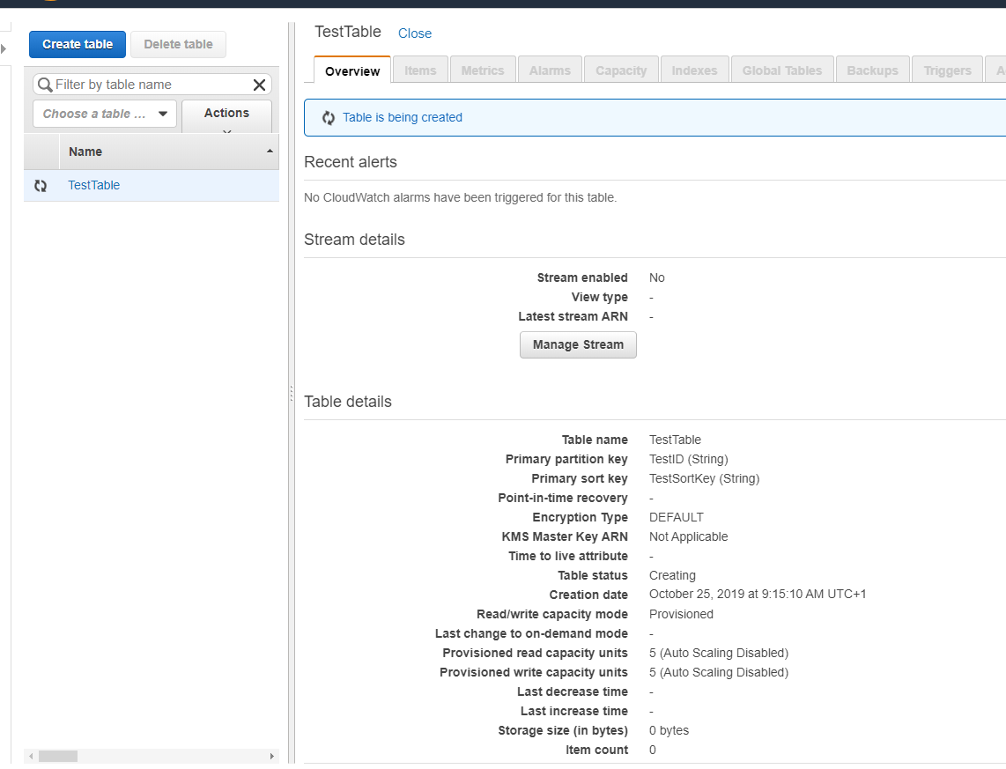
Figure AWS.DB.3

Step 6: Select Create Item. (Figure AWS.DB.4)
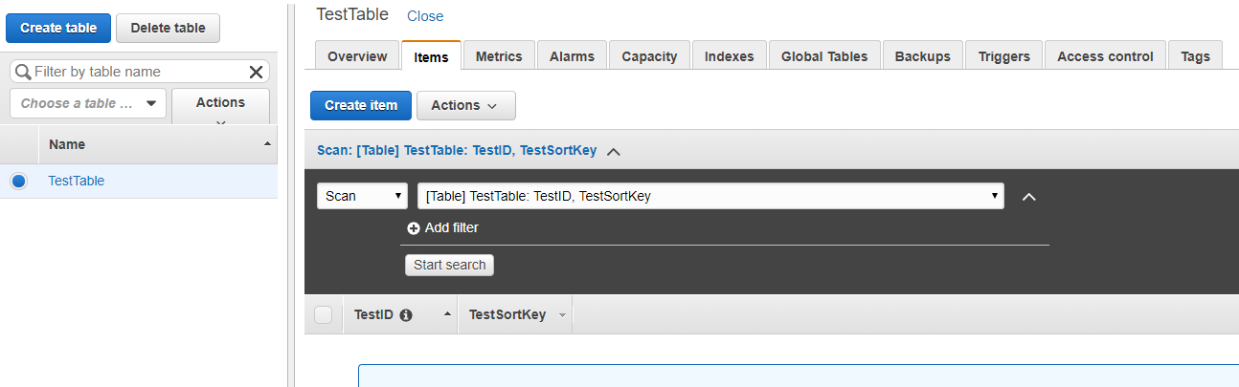
Figure AWS.DB.4

Step 7: Input the Item values. (Figure AWS.DB.5)

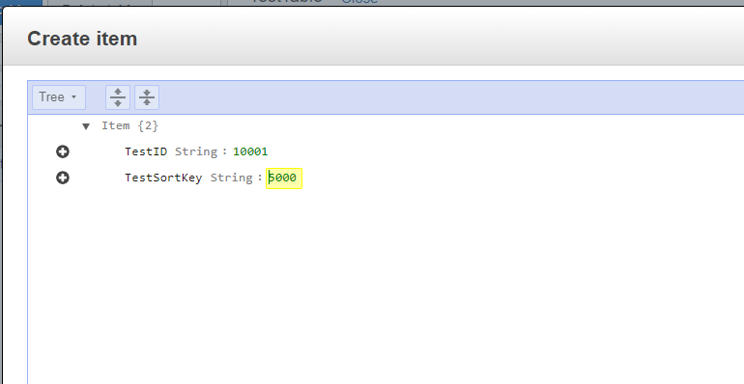
Figure AWS.DB.5

Step 8: View the Table Items. Figure AWS.DB.6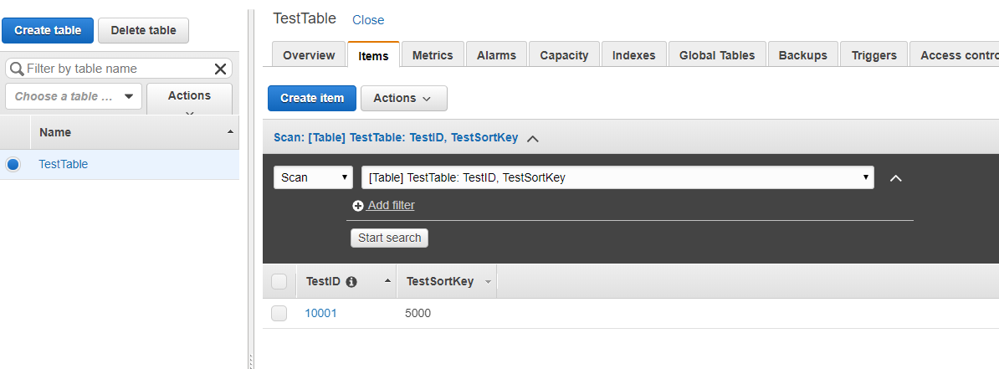
Figure AWS.DB.6

AWS WORKFLOW AND ORCHESTRATION

The AWS offering for Workflow and Orchestration is called the Step Functions service. In order to gain an understanding of the basic actions that are required to create a Workflow process using AWS Step Functions I will follow the Getting Started tutorials that are provided on the AWS website.

This small example will allow us to create a Step Function State Machine that contains a Task that will invoke the Lambda function that we created in the previous section.

Step 1: Create an IAM Role that will be used to allow the Step Function State Machine to invoke a Lambda function. (Figure AWS.STEP.1)

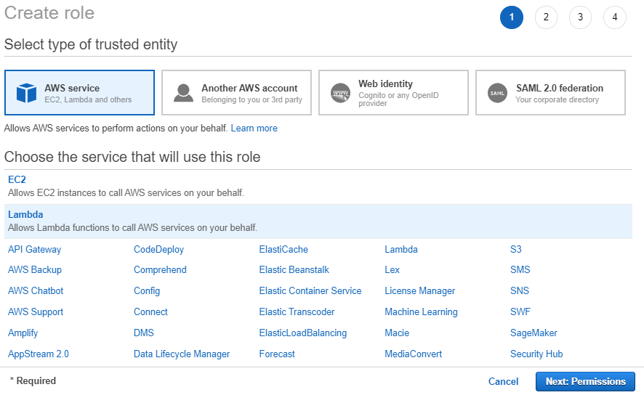
Figure: AWS.STEP.1

Step 2: Attach the AWSLambdaRole Policy to the new Role. (Figure AWS.STEP.2)
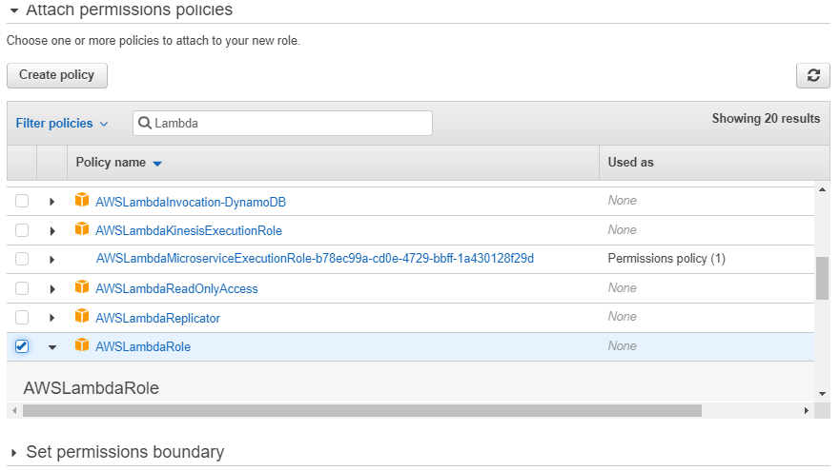
Figure AWS.STEP.2

Step 3: Name and Complete the Role creation. (Figure AWS.STEP.3)
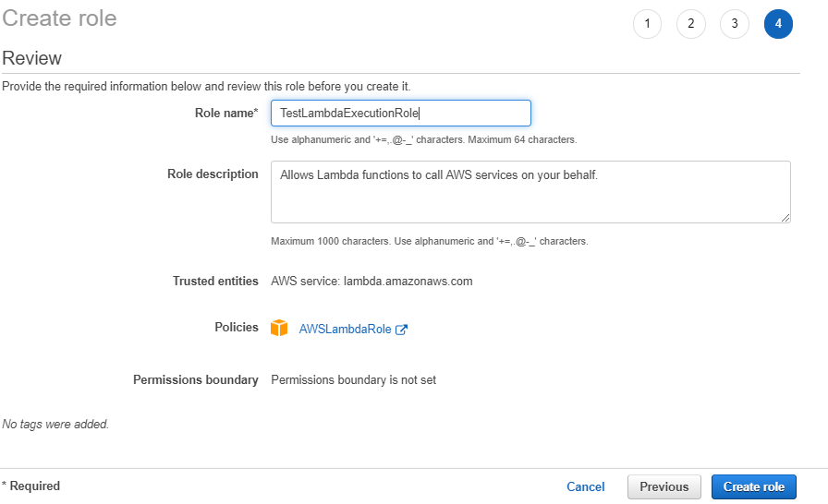
Figure AWS.STEP.3

Step 4: Create a new Step Function State Machine. (Figure AWS.STEP.4)
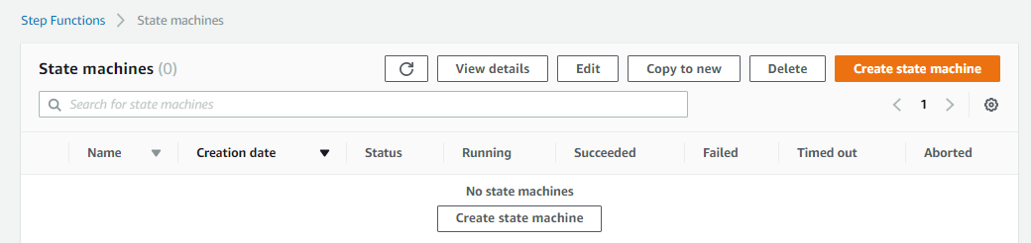
Figure AWS.STEP.4

Step 5: Select 'Author with code snippets'. (Figure AWS.STEP.5)
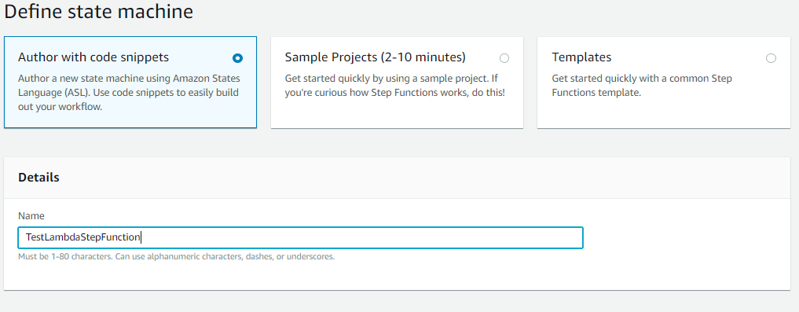
Figure AWS.STEP.5

Step 6: Define a Task state and specify the ARN for the existing Lambda. (Figure AWS.STEP.6)
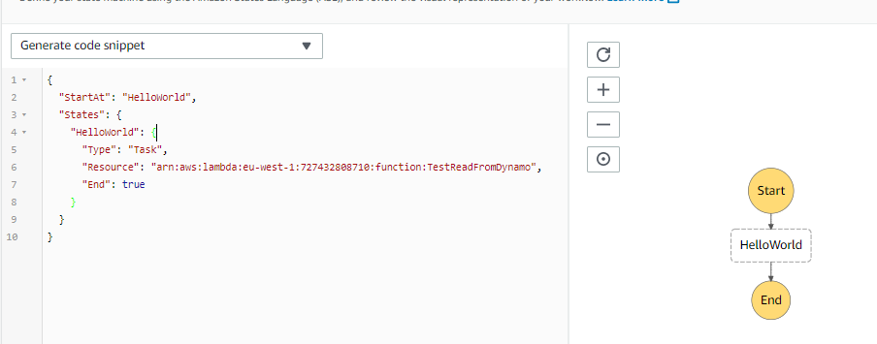
Figure AWS.STEP.6

Step 7: Choose the existing IAM Role. (Figure AWS.STEP.7)
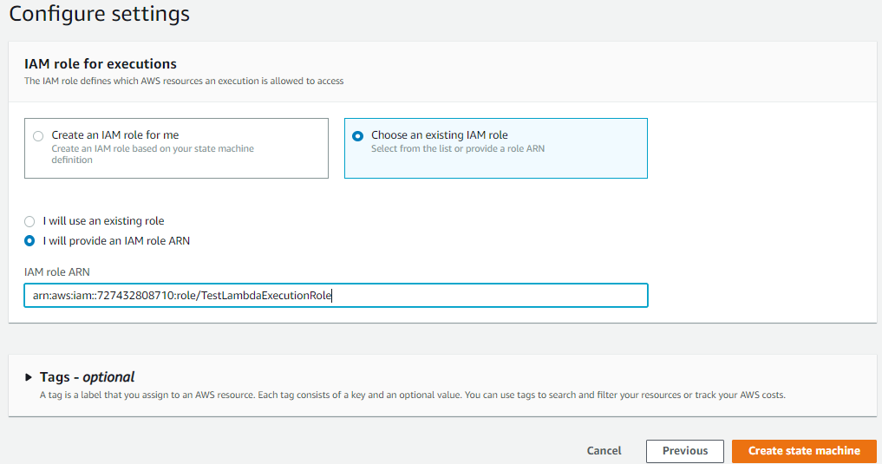
Figure AWS.STEP.7

Step 8: Create the State Machine and Save the ARN. (Figure AWS.STEP.8)
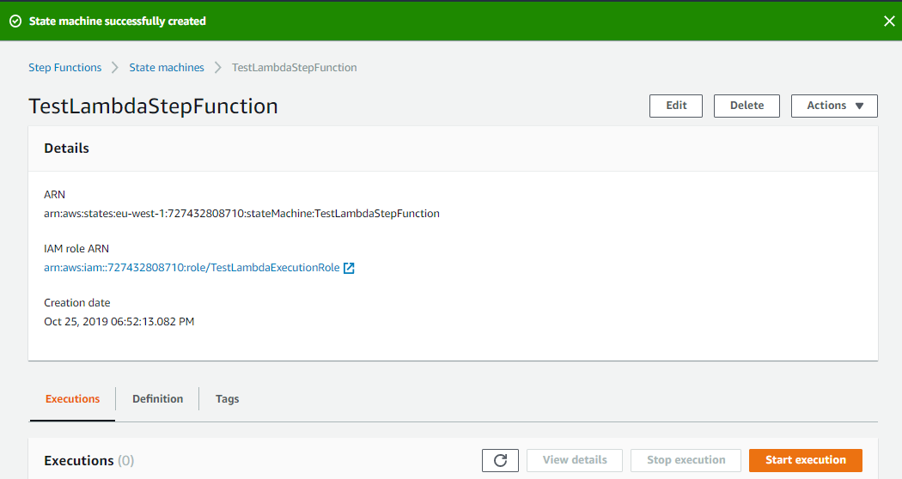
Figure AWS.STEP.8

Step 9: Test the new Step Function by creating a new Execution. (Figure AWS.STEP.9)
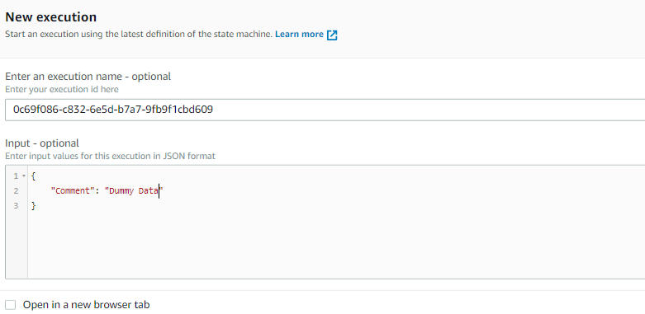
Figure AWS.STEP.9

Step 10: The Execution has failed. (Figure AWS.STEP.10, AWS.STEP.11)
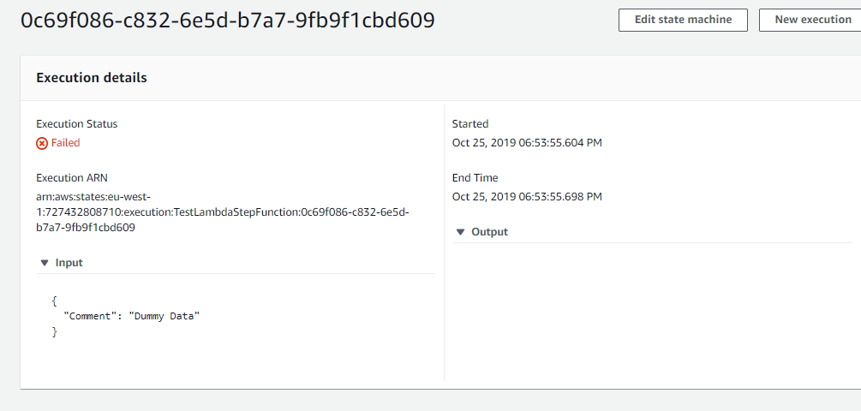
Figure AWS.STEP.10

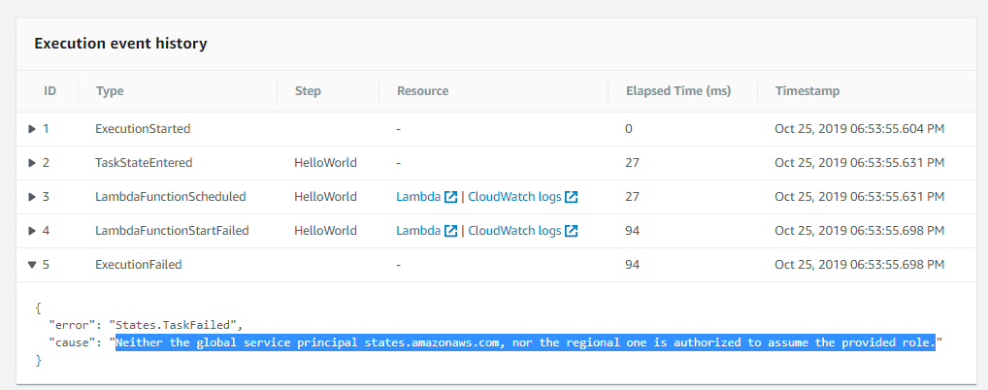
Figure AWS.STEP.11

After investigation, the error seems to be caused due to the Policy that was specified. It does not seem to be allowed to specify an unrestricted Resource section “*”. The error was overcome by specifying the Resource to be Lambda functions scoped to the specific AWS account.
"Action": [
"lambda:InvokeFunction"
],
"Resource": [
"*"
]

"Action": [
"lambda:InvokeFunction"
],
"Resource": [
"arn:aws:lambda:eu-west-1:727432808710:function:*"
]

Step 11: Amend the Policy Permission as shown below. (Figure AWS.STEP.12)
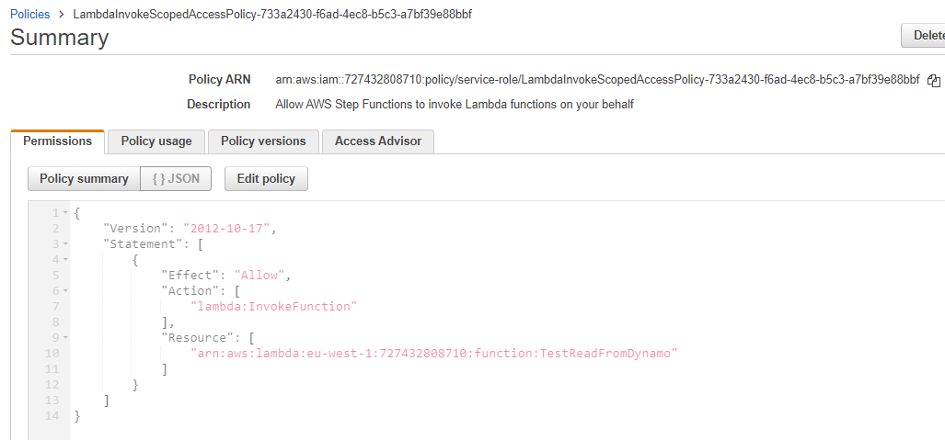
Figure AWS.STEP.12

Step 12: Retest the Step Function. (Figure AWS.STEP.13)
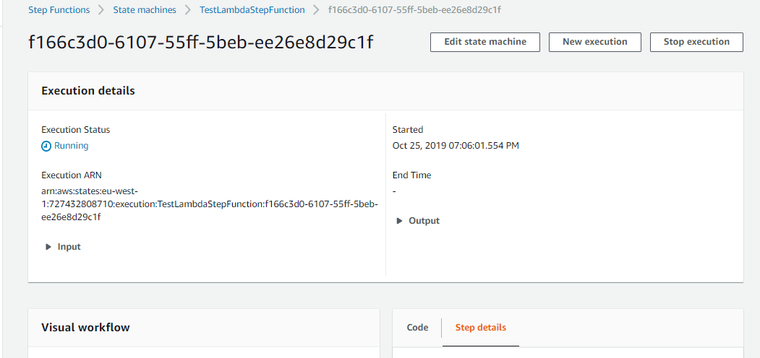
Figure AWS.STEP.13

Step 13: Note the Step Function Successful Output. (Figure AWS.STEP.14)
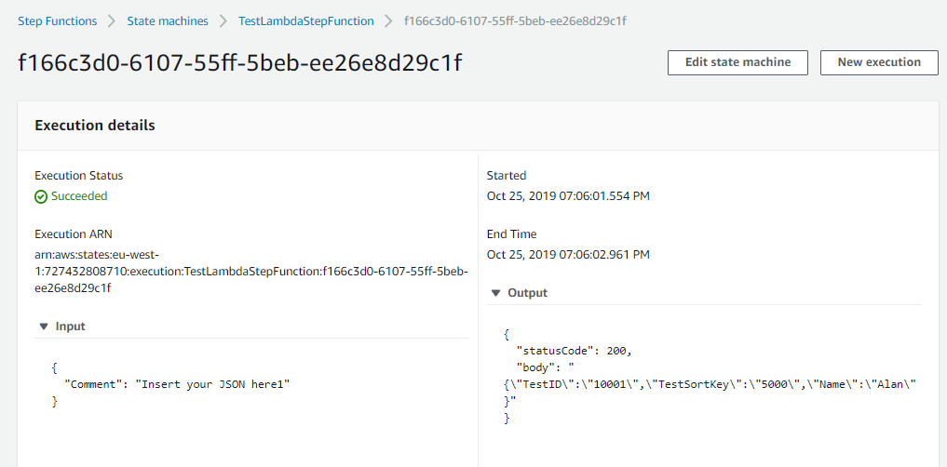
The output demonstrates that the Step Function invoked the Lambda function which responded with the DynamoDB table Item.

TECHNICAL DECISIONS
My investigations of the Azure and AWS Servlerless platforms as outlined in previous sections has allowed me to confirm that the AWS platform will be the cloud platform upon which I will develop this project.

In the two weeks of investigation I have formed the opinion that the developer experience and speed to market is superior on the AWS platform. In terms of ease of development and deployment, documentation, debugging, tooling I have found the AWS platform to be much more user friendly.

A percentage of this may be attributable to existing familiarity, but I have found the Azure documentation, support sites, technology stack to be below the standard I expected.

Therefore the technology resources the I will use are AWS services and open source development tools. The list is provided below.

1 NodeJS v13
2 Visual Studio Code
3 AWS DynamoDB
4 AWS Lambda
5 AWS Step Functions

PROJECT MILESTONES
The follow table lists the basic constituent components that are required to build the project implementation. This also give an indication of the milestone dates that should be met in order to deliver the project by the required date.

Due Date | Deliverables
3rd November | Workflow Design  CRUD Design  Database Schema
10th November | Database Build  CRUD API Build | Unit Testing
17th November | Component Services Design
24th November | Component Services Build | Unit + Integration Testing
1st December | Workflow Implmentation | Integration Testing
8th December | Workflow Implementation II | Integration Testing

REFERENCE LIST AND BIBLIOGRAPHY

Cloud Services FAQs
Google Cloud, Composer. https://cloud.google.com/composer/ (10 Oct, 2019)
Apache Airflow. https://airflow.apache.org/ (10 Oct, 2019)
Google Cloud, Functions. https://cloud.google.com/functions/ (10 Oct, 2019)
Google Cloud, Pub/Sub. https://cloud.google.com/pubsub/docs/ (10 Oct, 2019)
Google Cloud, Datastore. https://cloud.google.com/datastore/ (10 Oct, 2019)

Azure, Logic Apps. https://azure.microsoft.com/en-us/services/logic-apps/ (11 Oct, 2019)
Azure, Functions. https://azure.microsoft.com/en-us/services/functions/ (11 Oct, 2019)
Azure, Event Grid. https://azure.microsoft.com/en-us/services/event-grid/ (11 Oct, 2019)
Azure, Queue Storage. https://azure.microsoft.com/en-us/services/storage/queues/ (11 Oct, 2019)
Azure, ComosDB. https://docs.microsoft.com/en-us/azure/cosmos-db/introduction/ (11 Oct, 2019)

AWS, Step Functions. https://aws.amazon.com/step-functions/ (12 Oct, 2019)
AWS, Lambda. https://aws.amazon.com/lambda/ (12 Oct, 2019)
AWS, SNS. https://aws.amazon.com/sns/ (12 Oct, 2019)
AWS, SQS. https://aws.amazon.com/sqs/ (12 Oct, 2019)
AWS, Dynamo DB. https://aws.amazon.com/dynamodb/ (12 Oct, 2019)

Cloud Services Pricing

Google Cloud, Composer. https://cloud.google.com/composer/pricing/ (10 Oct, 2019)
Google Cloud, Functions. https://cloud.google.com/functions/pricing/ (10 Oct, 2019)
Google Cloud, Pub/Sub. https://cloud.google.com/pubsub/pricing/ (10 Oct, 2019)
Google Cloud, Datastore. https://cloud.google.com/datastore/pricing (10 Oct, 2019)
Google Cloud, Free Limits. https://cloud.google.com/free/ (10 Oct, 2019)

Azure, Logic Apps. https://azure.microsoft.com/en-us/pricing/details/logic-apps/ (11 Oct, 2019)
Azure, Functions. https://azure.microsoft.com/en-us/pricing/details/functions/ (11 Oct, 2019)
Azure, Event Grid. https://azure.microsoft.com/en-us/pricing/details/event-grid/ (11 Oct, 2019)
Azure, Queue Storage. https://azure.microsoft.com/en-in/pricing/details/storage/queues/ (11 Oct, 19)
Azure, ComosDB. https://azure.microsoft.com/en-us/pricing/details/cosmos-db/ (11 Oct, 2019)
Azure, Free Limits. https://azure.microsoft.com/en-us/free/#new-products

AWS, Step Functions. https://aws.amazon.com/step-functions/pricing/ (12 Oct, 2019)
AWS, Lambda. https://aws.amazon.com/lambda/pricing/ (12 Oct, 2019)
AWS, SNS. https://aws.amazon.com/sns/pricing/ (12 Oct, 2019)
AWS, SQS. https://aws.amazon.com/sqs/pricing/ (12 Oct, 2019)
AWS, Dynamo DB. https://aws.amazon.com/dynamodb/pricing/provisioned/ (12 Oct, 2019)
AWS, Free Limits. https://aws.amazon.com/free/

